Experiment No: 06
Problem Name: Implementation of Smoothing Linear Filters using Various Mask Sizes.
Objectives:
- To understand the concept of spatial domain linear filtering.
- To implement the Averaging (Smoothing) filter using different mask sizes 3x3, 5x5,7x7,9x9
- To observe the effect of increasing mask size on image blurring and noise reduction.
Theory: Image smoothing is a technique used in digital image processing to reduce noise and small variations in an image. A smoothing linear filter replaces each pixel value with the average value of its neighboring pixels.
The averaging filter is one of the most common smoothing filters. It uses a mask (kernel) such as 3×3, 5×5, 7×7, or 9×9. The filter works by convolving the mask over the image.
For example, a 3×3 averaging mask is:
$$\frac{1}{9}\left[\begin{matrix}1 & 1 & 1 \\ 1 & 1 & 1 \\ 1 & 1 & 1\end{matrix}\right]$$
Similarly, larger masks such as 5×5, 7×7, and 9×9 perform stronger smoothing because they average more neighboring pixels.
Code:
import cv2
import numpy as np
from matplotlib import pyplot as plt

image = cv2.imread('sm_pic.jpg')
image = cv2.cvtColor(image, cv2.COLOR_BGR2RGB)
smooth_3x3 = cv2.blur(image, (3, 3))
smooth_5x5 = cv2.blur(image, (5, 5))
smooth_7x7 = cv2.blur(image, (7, 7))
smooth_9x9 = cv2.blur(image, (9, 9))
titles = ['Original Image', '3x3 Filter', '5x5 Filter', '7x7 Filter', '9x9 Filter']
images = [image, smooth_3x3, smooth_5x5, smooth_7x7, smooth_9x9]
plt.figure(figsize=(15, 8))
for i in range(5):
plt.subplot(2, 3, i+1)
plt.imshow(images[i])
plt.title(titles[i])

plt.tight_layout()
plt.show()
Output:
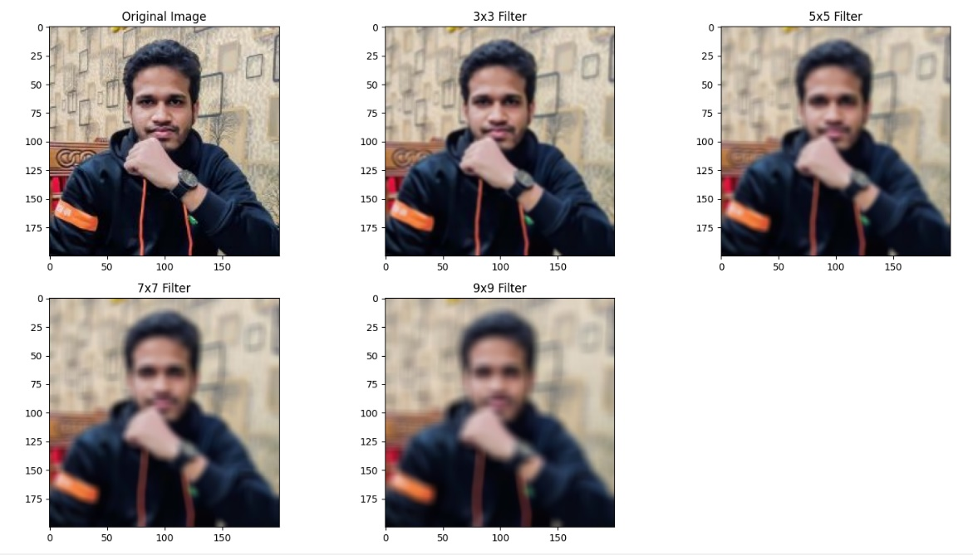
Result & Discussion: The program successfully applied smoothing linear filters using four different mask sizes: 3×3, 5×5, 7×7, and 9×9.
Observations:
- The 3×3 filter slightly reduced noise while preserving image details.
- The 5×5 filter produced smoother results with moderate blurring.
- The 7×7 filter significantly reduced noise but blurred edges more.
- The 9×9 filter created the smoothest image but removed many fine details.
The experiment shows that increasing the kernel size increases smoothing intensity. However, excessive smoothing may reduce important image information.

Analysis: Linear filtering is mathematically a convolution (or correlation) process. The mask contains coefficients (for an averaging filter, all coefficients are 1/n, where n is the number of pixels in the mask). A larger mask acts as a stronger low-pass filter, cutting off more high-frequency components (edges and noise) from the image.

Opinion: In this experiment, I implemented smoothing linear filters using different mask sizes in Python. I learned how averaging filters work and how kernel size affects image quality. I also understood the trade-off between noise reduction and image detail preservation. This experiment improved my practical knowledge of digital image processing and filtering techniques.

